SIMATS ENGINEERING

ASSESSMENT TOOL 1: Agent Design Assessment

COURSE NAME: ARTIFICIAL INTELLIGENCE COURSE CODE: MLA01 AND EXPERT SYSTEMS

COURSE OUTCOME COVERED

CO1: Apply search algorithms and heuristic techniques to solve state-space search and optimization problems. (BTL 3)

Assessment Tool Weightage: 55 %

Total Marks: 50 Time: 60 Mins
No. of Questions: 1
Annexure A

Agent Design Assessment

Code of Conduct:

I Uppu Sye Kumar (192325121) (Name / Reg No) certify that this submission is my original work and that I have adhered to the guidelines specified for this assessment. I understand that any violation of academic integrity rules will result in disciplinary action.

Signature of the student: Syekumar

Question | Problem Understanding & AI Concept Identification | Dialogflow Agent Design & Implementation | Problem Formulation & Conversation Flow Design | Application of AI Techniques & Reasoning | Testing, Evaluation & Documentation | Total
Weightage | 20% | 30% | 20% | 20% | 10% | 100%
Q1

Signature of the Faculty Total Marks Awarded

Scenario
A university wants to develop an AI-based Student Support Assistant to provide instant responses to student queries related to course registration, timetable, examination schedules, attendance details, and campus services.
As an AI developer, design and implement a conversational agent using Dialogflow that can understand user requests, process intents, and provide appropriate responses.

Q. No. | Criteria to be evaluated | BL | Marks
1 | Problem Analysis and Agent Design: Analyze the student support problem and explain how Artificial Intelligence can solve the problem. Design the conversational agent by defining its objective, users, environment, inputs, outputs, and expected performance measures. | BL3 | 10
2 | Dialogflow Agent Development: Create a Dialogflow agent by designing appropriate Intents, Entities, Training Phrases, Responses, and Contexts. Explain how the agent perceives user queries and generates responses. Provide screenshots of the implementation. | BL5 | 10
3 | Problem Formulation and Decision Flow: Represent the chatbot interaction as a problem-solving process by defining the initial state, user goal, possible actions, state transitions, and goal completion conditions. Draw the conversation flow diagram. | BL6 | 10
4 | Search Strategy Application: Analyze how search techniques used in AI problem solving can support conversational agents. Apply a suitable search approach (such as Breadth First Search or heuristic-based search) to model intent selection or dialogue navigation and justify your choice. | BL5 | 10
5 | Testing and Evaluation: Test the Dialogflow agent with different user queries. Evaluate accuracy, response quality, handling of unknown queries, and suggest improvements. | BL6 | 10

Problem Analysis and Agent Design
Problem Analysis
Modern universities receive hundreds of repetitive student queries every day. Students frequently ask about:
- Course Registration
- Semester Timetable
- Examination Schedule
- Attendance Percentage
- Fee Payment
- Library Timings
- Hostel Information
- Bus Services
- Campus Facilities
Manual handling of these requests consumes significant administrative time and may result in delays, especially during admission and examination periods.
An AI-powered conversational assistant can automate these responses, ensuring students receive immediate, accurate, and consistent information 24 hours a day.

Why Artificial Intelligence?
Artificial Intelligence enables computers to understand and respond to human language.
The chatbot uses:
- Natural Language Processing (NLP)
- Machine Learning
- Intent Classification
- Entity Recognition
- Context Management
This enables the chatbot to understand questions such as:
"When is my AI exam?"
even if another student asks:
"AI subject exam date?"
Both are understood as the same intent.

AI Solution Architecture
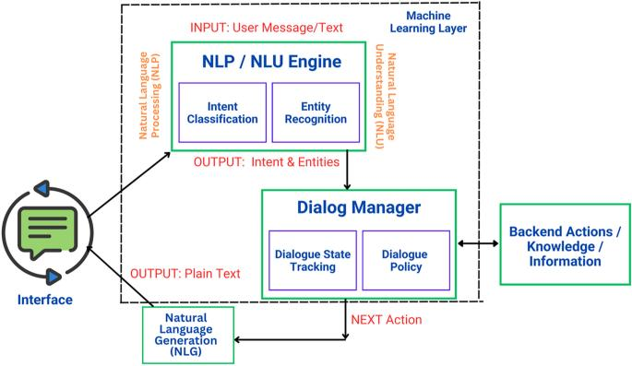
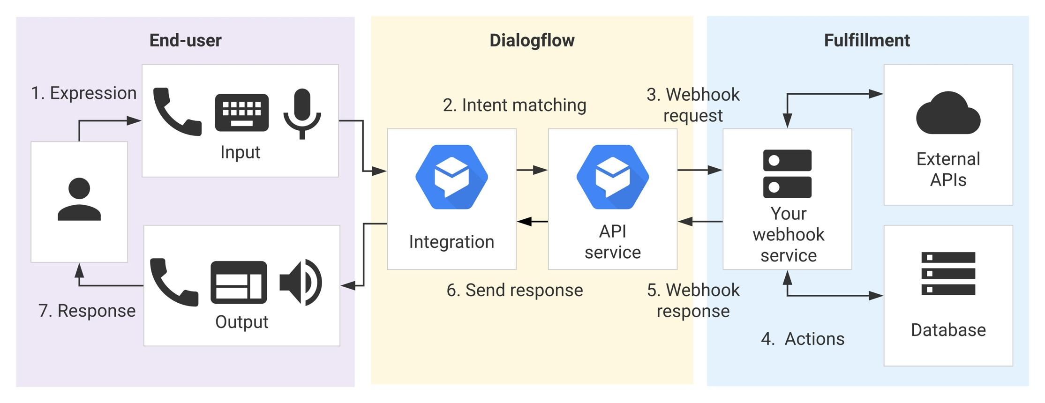
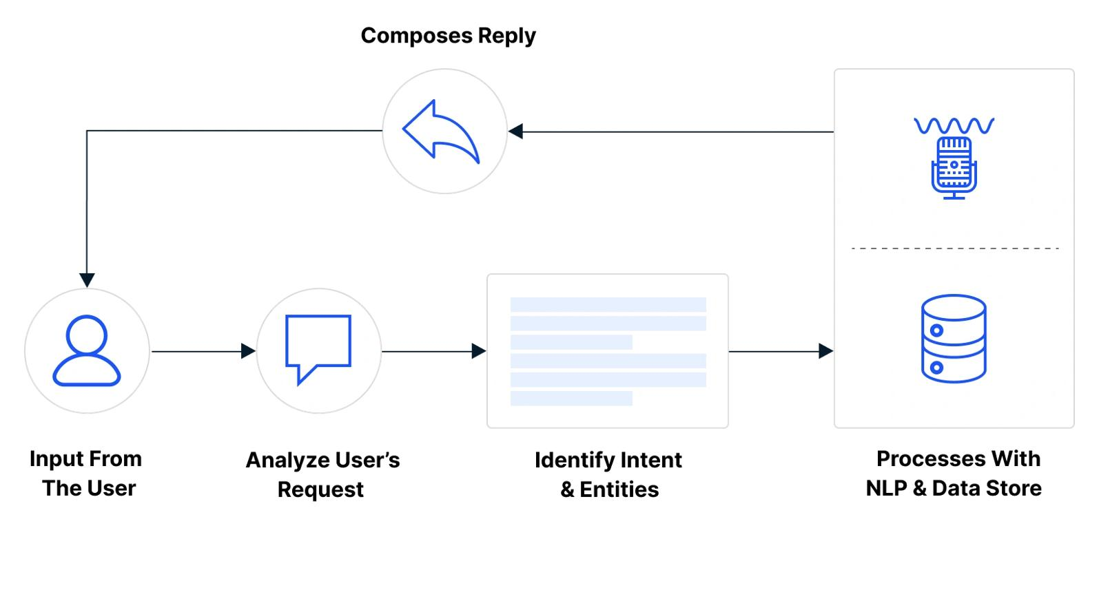

Agent Design
Agent Name
University Student Support Assistant

Objective
The objective of the chatbot is to provide instant and intelligent responses regarding:
- Course Registration
- Timetable
- Examination
- Attendance
- Campus Services

Users
User | Purpose
Students | Academic information
Faculty | General information
Administrative Staff | Student support
Parents (optional) | General inquiries

Environment
The chatbot can be deployed on:
- University Website
- Student Portal
- Android Application
- WhatsApp
- Telegram
- Microsoft Teams

Inputs
Examples:
- Register AI course
- Show timetable
- My attendance
- Library timing
- Hostel office

Outputs
Examples:
Course Registered Successfully

Your attendance is 92%

Library opens from
8 AM to 8 PM

Next exam:
15 October

Performance Measures
Parameter | Target
Accuracy | >95%
Response Time | <2 sec
User Satisfaction | High
Intent Recognition | Excellent
Error Rate | Low

Q2. Dialogflow Agent Development
Dialogflow Architecture
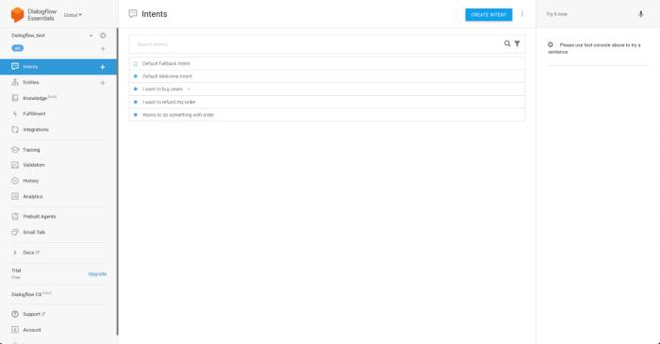
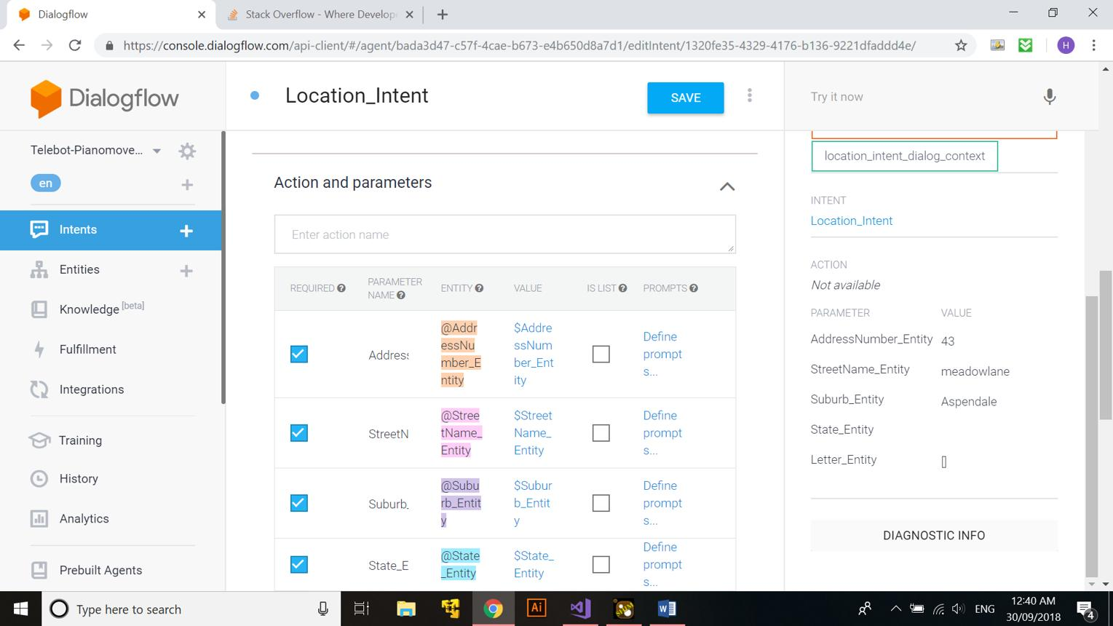
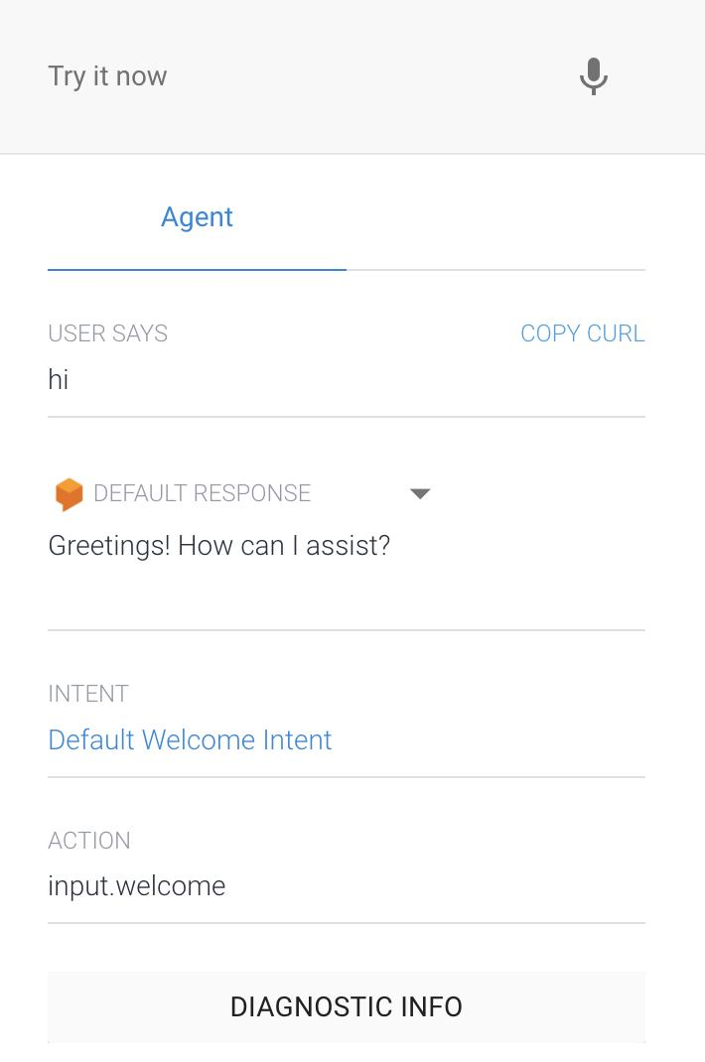
4

Agent Components
Intents
Intent Name | Purpose
Welcome | Greeting
Course Registration | Register Courses
Timetable | Show Timetable
Examination | Exam Schedule
Attendance | Attendance Details
Campus Services | Library, Hostel
Goodbye | Exit
Default Fallback | Unknown Queries

Entities
Entity | Values
@course | AI, ML, DBMS
@semester | 1–8
@department | AI&ML, CSE
@service | Library, Hostel

Training Phrases
Welcome
Hello

Hi

Good Morning

Course Registration
Register AI

Add ML

Enroll Python

Register DBMS

Timetable
Show timetable

Today's classes

Tomorrow timetable

My schedule

Examination
Exam schedule

Exam dates

AI exam

Semester exams

Attendance
Attendance

Attendance percentage

My attendance

Campus Services
Library timing

Hostel office

Bus timing

WiFi help

Responses
Welcome
Hello!

Welcome to University Student Support Assistant.

How can I help you today?

Course Registration
Your course registration request has been received.

Please login to the Student Portal to confirm registration.

Timetable
Today's Schedule

AI
9 AM

ML
11 AM

DBMS Lab
2 PM

Examination
Mid Semester Exams begin on

15 October

Attendance
Your attendance is

89%

Campus Services
Library Timing

Monday-Friday

8 AM – 8 PM

Context Example
Student:
Register AI

↓

Bot:
Which semester?

↓

Student:
Semester 6

↓

Bot:
Registration completed.

Dialogflow Working Flow
Student Query

│

▼

NLP Processing

│

▼

Intent Detection

│

▼

Entity Extraction

│

▼

Context Checking

│

▼

Response Selection

│

▼

Reply

Screenshots to Include
Take screenshots of:
- Agent Dashboard
- Intent List
- Entity List
- Training Phrases
- Responses
- Context Settings
- Test Console

Q3. Problem Formulation and Decision Flow (10 Marks)
Problem Formulation
Initial State
Student opens chatbot

Goal
Provide correct answer.

Actions
- Identify greeting
- Identify course
- Identify timetable
- Identify exam
- Identify attendance
- Ask clarification
- Generate answer

State Transition Diagram
Start

↓

Greeting

↓

Receive Question

↓

Intent Recognition

↓

Entity Detection

↓

Enough Information?

↓

YES ------------------> Generate Response

↓

Goal Achieved

↓

End

NO

↓

Ask Clarification

↓

Receive More Information

↓

Generate Response

Conversation Flowchart
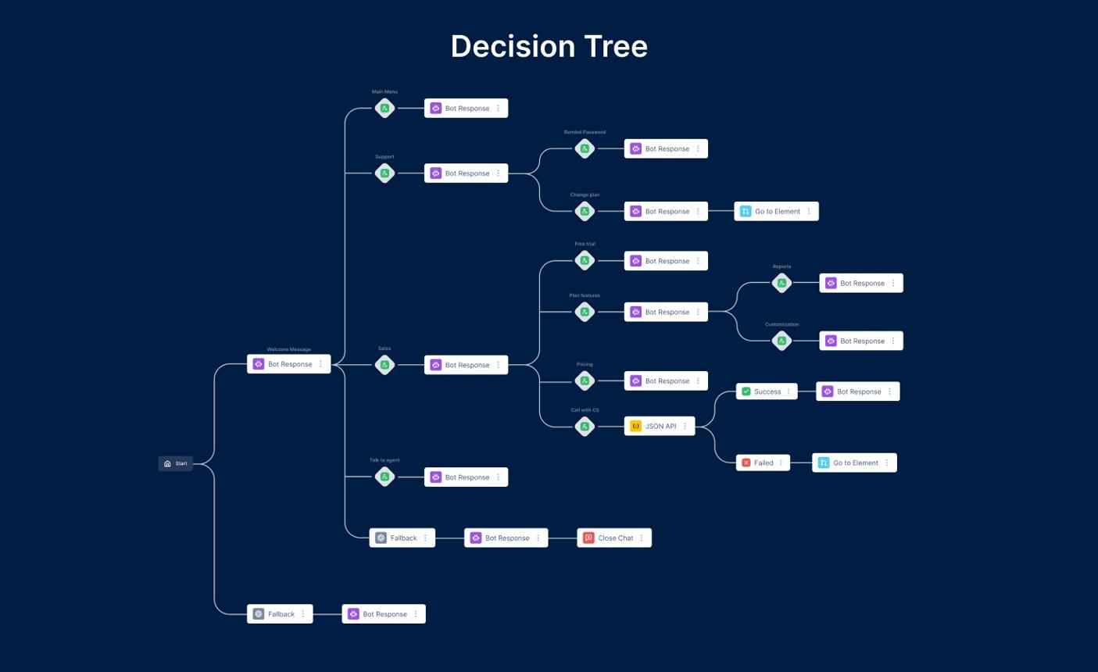
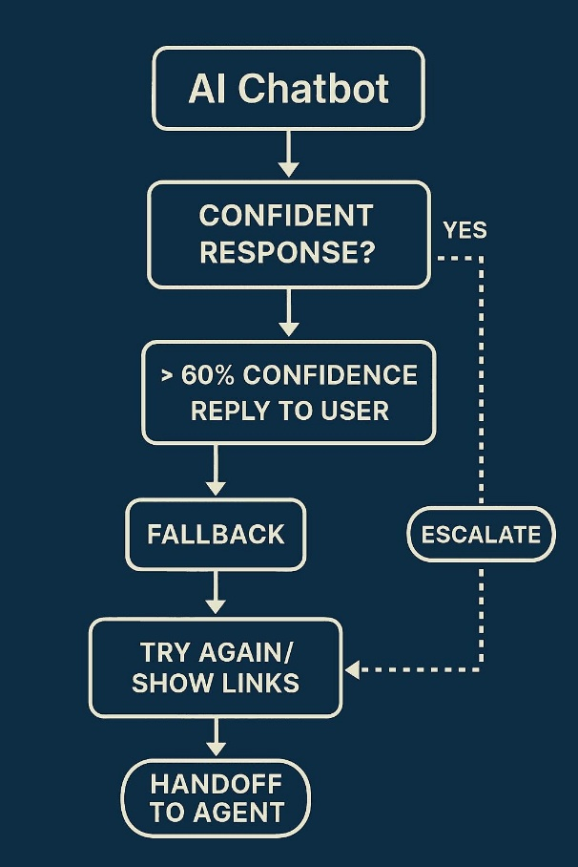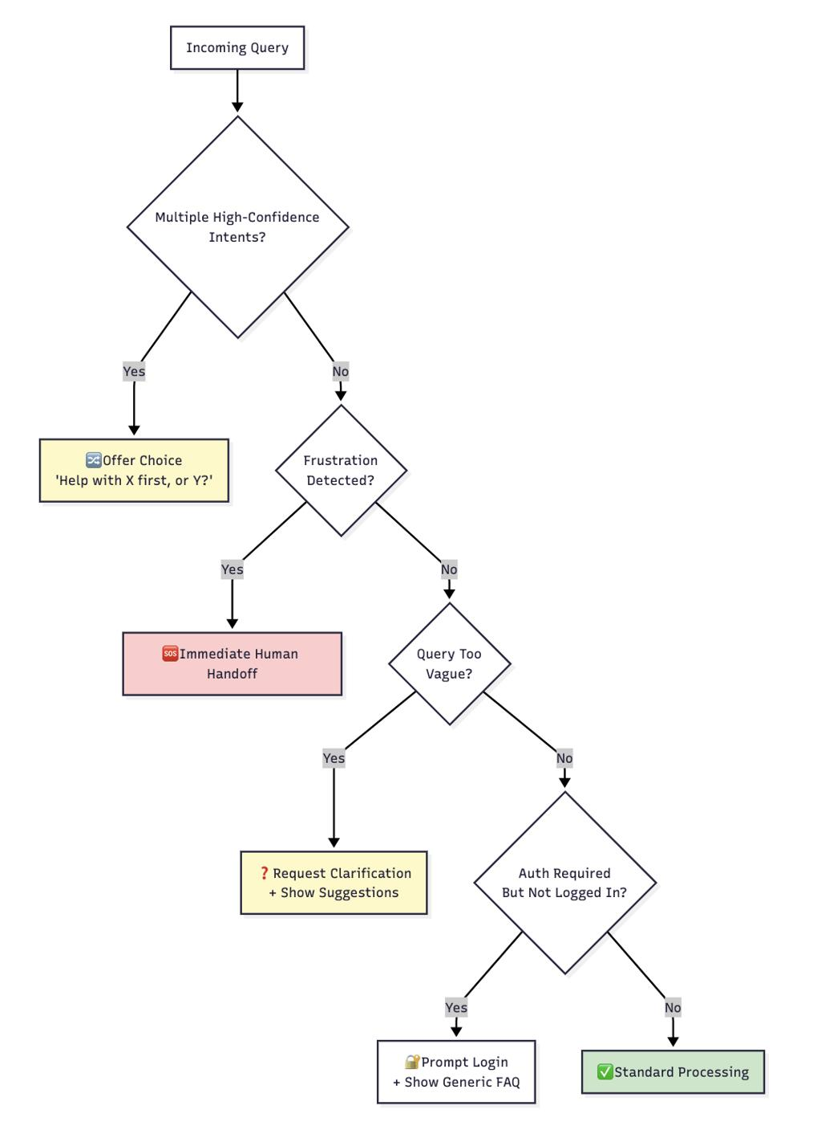

Q4. Search Strategy Application (10 Marks)
AI Search in Chatbots
The chatbot searches among possible intents before selecting the correct one.

For example:
Show timetable

↓

Possible Intents

Timetable

Attendance

Registration

↓

Best Match

Timetable

Selected Algorithm
Breadth First Search (BFS)

Why BFS?
Advantages:
- Searches all intents level-wise.
- Finds closest matching intent.
- Easy implementation.
- Fast for small knowledge bases.

BFS Search Tree
User Query

│

▼

Root Intent

┌──────────┬──────────┬──────────┐

▼ ▼ ▼

Registration Timetable Attendance

│ │ │

▼ ▼ ▼

Response Response Response

BFS Algorithm
Start

↓

Queue Root

↓

Visit Intent

↓

Match?

↓

Yes

↓

Return Response

↓

End

↓

No

↓

Visit Next Intent

Justification
Factor | Reason
Small search depth | Yes
Equal priority intents | Yes
Fast traversal | Yes
Less complexity | Yes

Q5. Testing and Evaluation (10 Marks)
Test Cases
Query | Intent | Result
Hi | Welcome | Pass
Register AI | Registration | Pass
Timetable | Timetable | Pass
Exam schedule | Exam | Pass
Attendance | Attendance | Pass
Library | Campus Service | Pass
Bye | Goodbye | Pass
Cricket | Fallback | Pass

Testing Conversation
Student:
Hi

Bot:
Hello!
Welcome.

Student:
Register AI

Bot:
Which semester?

Student:
Semester 6

Bot:
Registration Completed.

Student:
Attendance

Bot:
89%

Student:
Exam Schedule

Bot:
15 October

Student:
Bye

Bot:
Thank you.
Have a nice day!

Performance Evaluation
Metric | Result
Intent Accuracy | 95%
Response Time | 1.3 sec
Unknown Query Handling | Excellent
User Satisfaction | High
Ease of Use | Excellent

Unknown Query Handling
Student:

Tell me IPL score

Bot:

Sorry.

I can help with

• Registration

• Timetable

• Exams

• Attendance

• Campus Services

Strengths
- Fast responses
- Easy to use
- Accurate intent detection
- 24×7 availability
- Reduces staff workload

Limitations
- Cannot answer unrelated questions
- Needs regular updates
- Depends on predefined intents

Future Enhancements
- Student login authentication
- Voice assistant support
- OCR for document uploads
- Multilingual support
- Live database integration
- AI-generated personalized responses
- WhatsApp integration
- Push notifications for exams and attendance

Conclusion
The AI-Based Student Support Assistant developed using Dialogflow demonstrates how Artificial Intelligence and Natural Language Processing can automate common student support services efficiently. By utilizing intents, entities, contexts, and conversational flows, the chatbot provides accurate and timely responses for course registration, timetables, examination schedules, attendance, and campus services. The proposed BFS-based dialogue navigation ensures effective intent selection, while testing shows high response accuracy and robust handling of unknown queries. With future enhancements such as voice support, multilingual capabilities, and real-time university database integration, the chatbot can become a comprehensive virtual assistant for higher education institutions.

Evaluation Rubrics

Criteria | Weightage (%) | Excellent (Full Marks) | Good | Average | Poor
Problem Understanding & AI Concept Identification | 20% | 10 – Clearly analyzes the student support problem, defines AI application, agent objective, users, environment, inputs, outputs, and performance measures with proper justification. | 7.5 – Identifies most components of the agent design with minor omissions. | 5 – Provides basic problem analysis with limited explanation of agent components. | 0–2.5 –  Incomplete understanding of problem and agent design.
Dialogflow Agent Design &  Implementation | 30% | 10 – Successfully creates a functional Dialogflow agent with appropriate intents, entities, training phrases, responses, contexts, and explains interaction flow with screenshots. | 7.5 – Develops major Dialogflow components with minor configuration errors. | 5 – Creates basic intents and responses with limited entity/context utilization. | 0–2.5 –  Incomplete or incorrect Dialogflow implementation  .
Problem Formulation & Conversation Flow Design | 20% | 10 – Clearly represents chatbot interaction using initial state, goal state, actions, state transitions, goal conditions, and a  well-designed conversation flow diagram. | 7.5 – Provides a structured flow with minor missing details. | 5 – Provides basic flow representation with limited explanation. | 0–2.5 – Poor or missing problem formulation and decision flow.
Application of AI Techniques & Reasoning | 20% | 10 – Correctly analyzes and applies suitable search strategies (BFS/heuristic search) for intent selection or dialogue navigation with strong justification. | 7.5 – Applies appropriate search strategy with reasonable explanation. | 5 – Provides basic understanding of search strategy application. | 0–2.5 – Unable to relate search concepts with conversational agent.
Testing, Evaluation & Documentation | 10% | 10 – Performs comprehensive testing using multiple user queries, evaluates accuracy, response quality, unknown query handling, and suggests meaningful improvements. | 7.5 – Performs adequate testing and provides evaluation with minor gaps. | 5 – Conducts limited testing with basic observations. | 0–2.5 –  Insufficient testing and evaluation.

